1. Suppose you have a file named "data.txt" containing important information. Display the

first 10 lines of this file to quickly glance at its contents using a command.

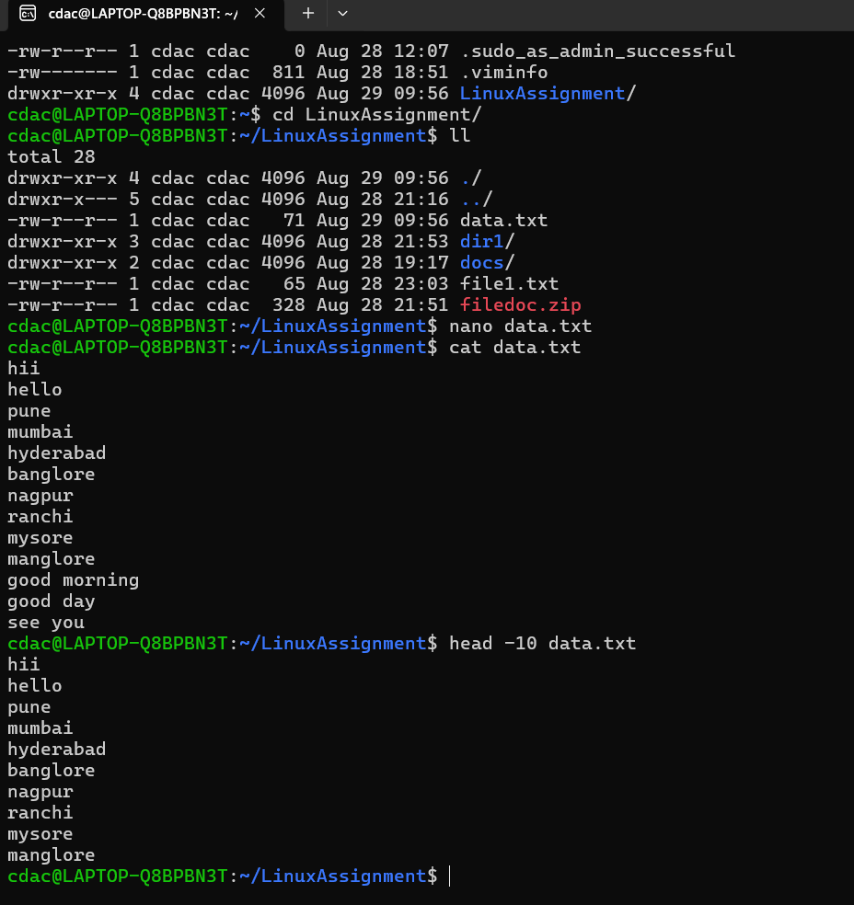

2. Now, to check the end of the file for any recent additions, display the last 5 lines of

"data.txt" using another command.

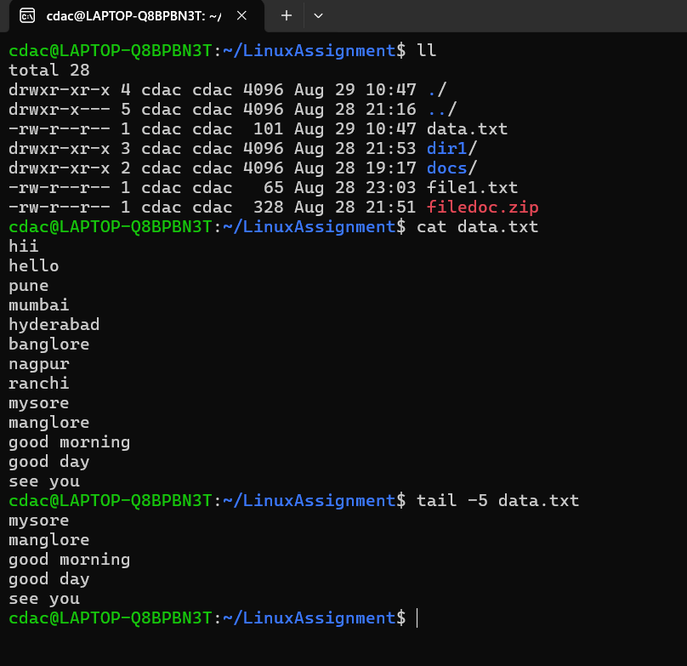

3. In a file named "numbers.txt," there are a series of numbers. Display the first 15 lines of

this file to analyze the initial data set.

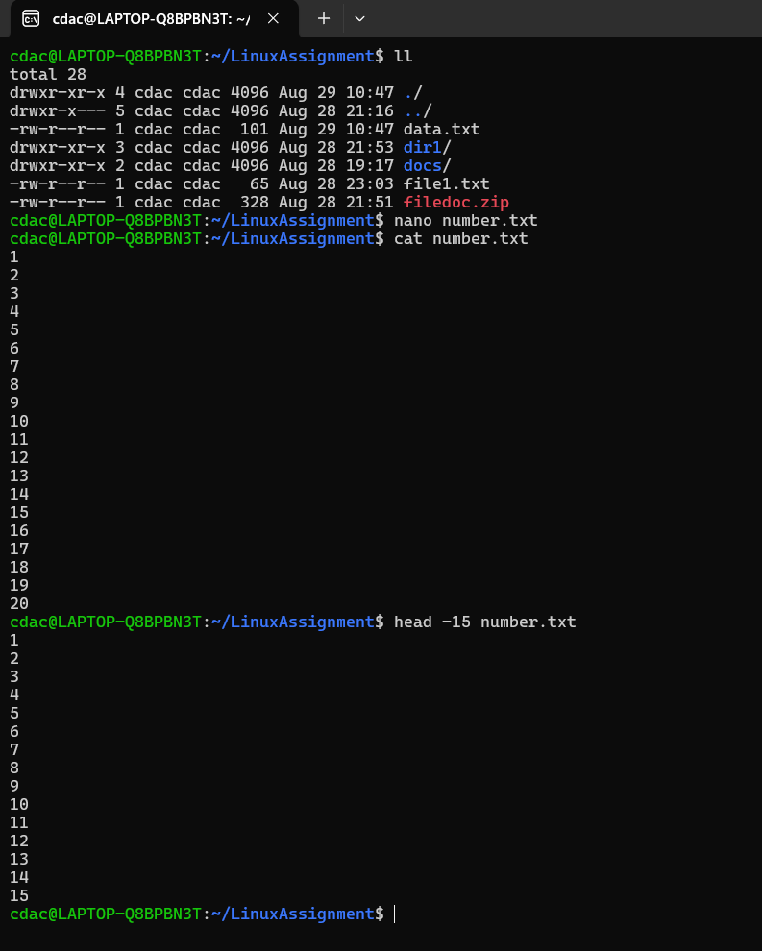

4.To focus on the last few numbers of the dataset, display the last 3 lines of "numbers.txt".

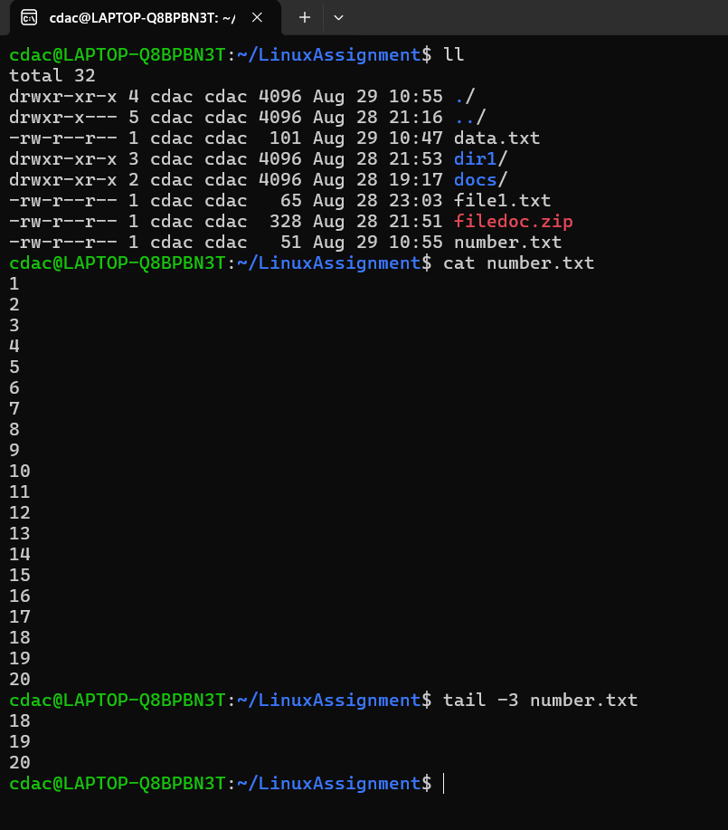

5. Imagine you have a file named "input.txt" with text content. Use a command to translate

all lowercase letters to uppercase in "input.txt" and save the modified text in a new file

named "output.txt."

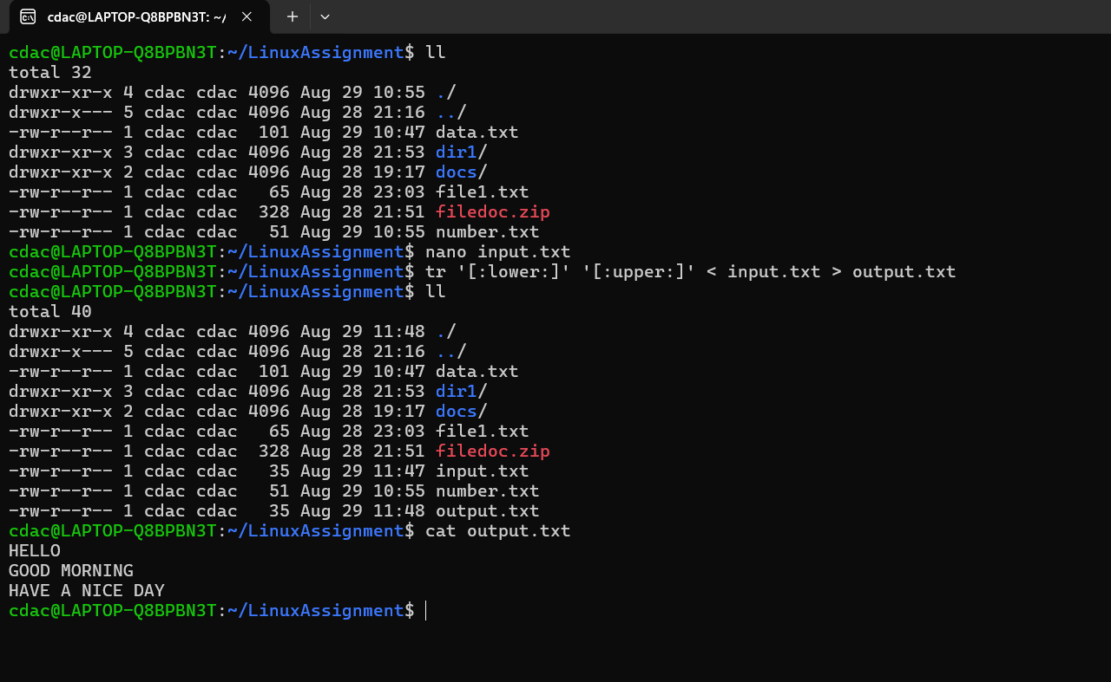

6. In a file named "duplicate.txt," there are several lines of text, some of which are

duplicates. Use a command to display only the unique lines from "duplicate.txt."

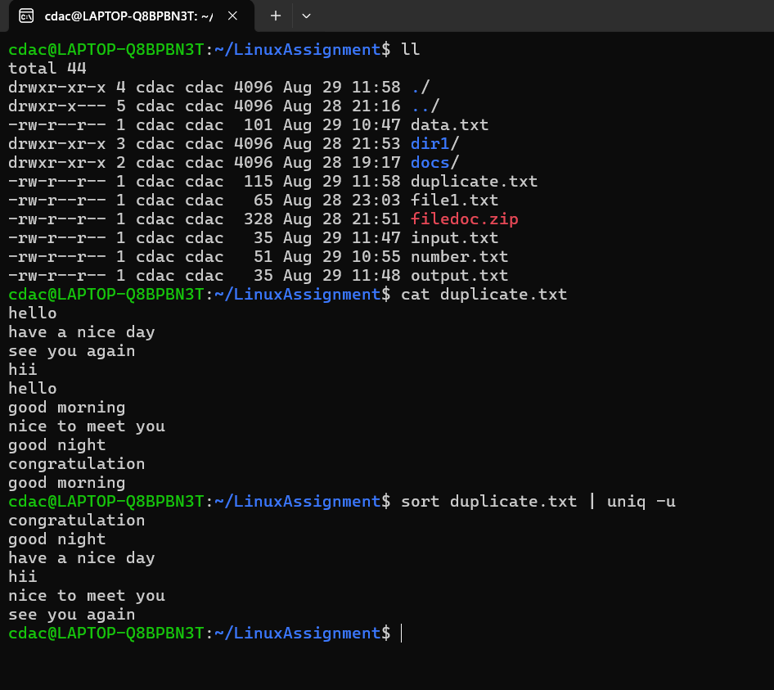

7. In a file named "fruit.txt," there is a list of fruits, but some fruits are repeated. Use a

command to display each unique fruit along with the count of its occurrences in

"fruit.txt."

